



Implement a segment tree
LAB MANUAL

Disclaimer: The content is curated from online/offline resources and used for educational purpose only
Design and implement a segment tree that supports range minimum queries and point updates. Test it on dynamic data streams.

Objective:
Design and implement a segment tree to support range minimum queries and point updates. Test and evaluate the implementation on dynamic data streams.
Problem Statement:
Develop a segment tree that allows:
1. Efficient range minimum queries (RMQ)
2. Point updates on dynamic data
Then, test the segment tree with a stream of data changes and query results.

Equipment Required:
- Python installed with Jupyter Notebook

Prerequisites:
- Understanding of arrays and range queries
- Basic programming knowledge in Python
- Familiarity with recursive functions

Procedure:
Step 1: Segment Tree Class Definition
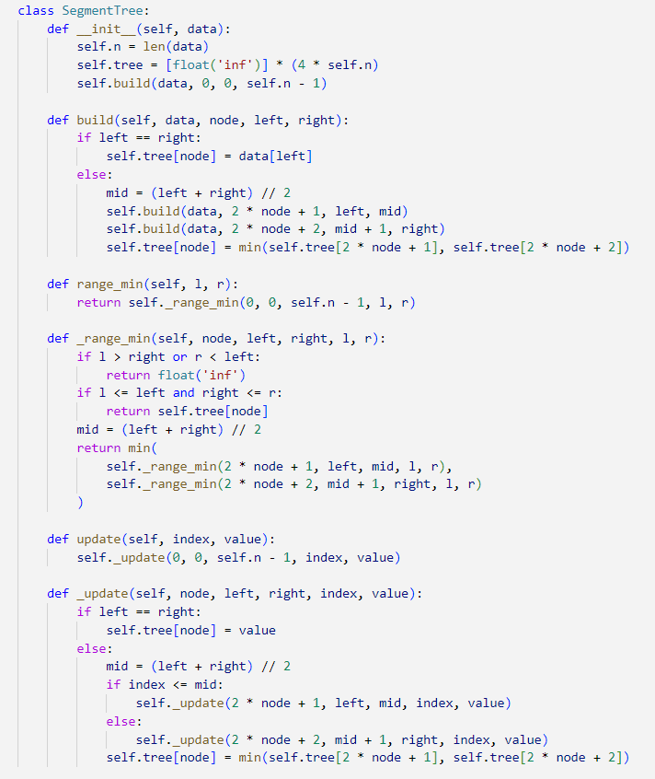

Step 2: Testing the Segment Tree

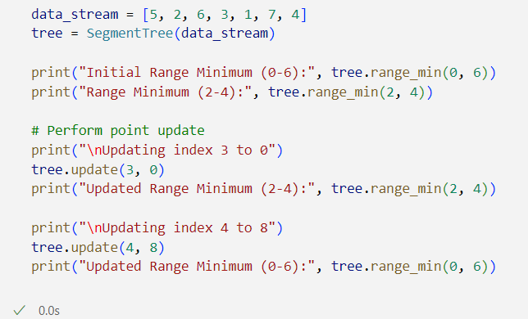

Output:
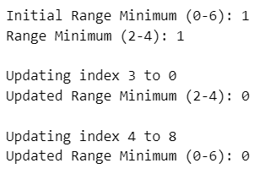
Conclusion
This lab demonstrated the design and implementation of a segment tree for solving range minimum queries and point updates. The tree structure efficiently handles dynamic changes in the dataset while maintaining fast query responses, making it suitable for real-time monitoring systems, stock price analysis, and sensor data processing.

